******Kindy/Pre-Primary Class Newsletter**

**Week 2 Term 3, 2020**

**Term 3 Is Here**

Welcome back for another wonderful term of fun and learning in Kindy/Pre-Primary. The children returned to school last week full of energy and stories about their holidays. It was lovely to listen to each of them sharing some of the fun things they did over the holidays.

This term is jam packed with a range of extra curricula events taking place. Please either refer to the Term Planner sent home with last week’s newsletter or the “Up Coming Events” section of this newsletter to ensure you don’t miss anything.

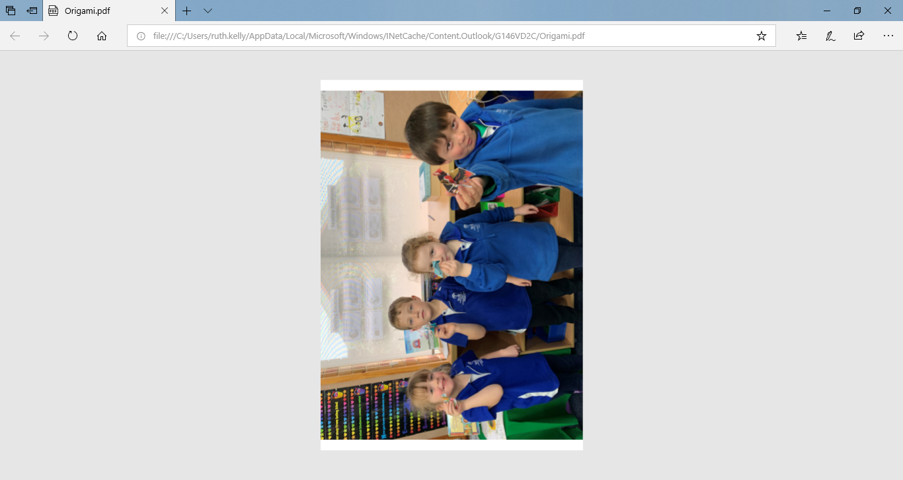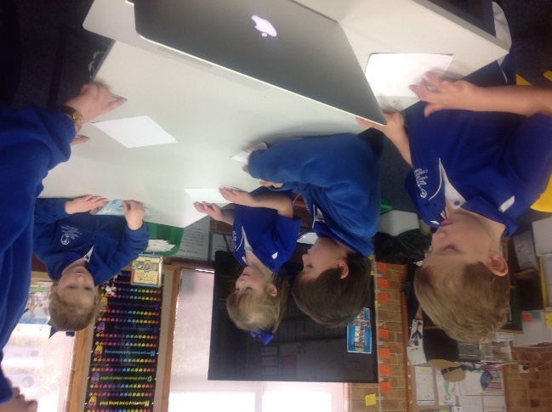

Origami Creations in Options:

From this flat piece of paper a few folds and…

Tada!

**Options**

It was with great excitement that the Pre-Primary students joined the rest of the school for the start of our annual Options program last Thursday.

This is a great opportunity for the children to mix with students from different grades and try their hand at a new skill.

Please remember that on Thursday Week 7 (3rd September) the children will share what they have been learning at the Options Showcase. We hope you can make it.

**English and Maths**

This term we will begin to explore information texts in English. This genre will be closely linked to our Inquiry focus – “How do Machines help us?” Students will have the opportunity to research how different machines help people and write and illustrate a simple information report.

During Maths we will begin the term focusing on number and how to tell and solve simple addition and subtraction stories. Before moving on to measurement. We will learn about how to measure and compare the length, mass and capacity of different objects.

**Cardboard Box “Friends”**

We started our term with the shared book “Cardboard Friend”. Using this book as their inspiration the students each drew a detailed plan of their own cardboard box friend. Then using their plan and materials and boxes from the classroom they made their own “Cardboard Box Friend”. The Pre-Primary students also wrote a descriptive piece of writing explaining who their “Cardboard Box Friend” was and some of its special features.

**Religion**

We will continue with our study of the Eucharist and its special place in the Mass for a short time, before we will turn our attention to St Mary MacKillop. The class will be hosting the schools Liturgy dedicated to St Mary MacKillop. To ensure we have a really good understanding of what an inspirational person and WESTie St Mary MacKillop was, before our Liturgy we will spend some time learning about her life and motto “Never see a need without doing something about it”. As some of our Year 6 students prepare for Confirmation, we will also learn a little about what the sacrament of Confirmation is and why it an important sacrament within the Church.

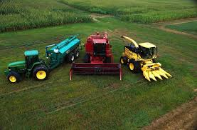

**School Photos**

This term the schools annual school photos will take place on **Thursday 27th August in the morning.**

Unfortunately, we were unable to lock in a date for photos this year that coincided with our Kindergarten days.

However, our Kindies are very much part of our school and class, so we ask that you try to bring your child along first thing in the morning for their first ever school individual and class photos. We will ensure that the K/Pp class goes first so you can leave as soon as possible after the photographs are taken.

Inquiry – How do Machines Help Us?

Many of the students have a great interest in machines, especially machinery used in and around farms.

Our first inquiry focus for the term will be linked to exploring how machines help people. Depending on the student’s engagement and wonder questions we also hope to explore how machines work and possibly even design our own machines that can help people do different jobs.

**Up Coming Events**

* **St Mary MacKillop Liturgy K/Pp** Wednesday 19th August @ 9.00am
* **St Mary MacKillop Feast Day Events** Wednesday 19th August (details to come closer to the day)
* **P&F and Board Meeting** Wednesday 19th August @ 5.30pm
* **Confirmation** Sunday 23rd August @ 10.30am
* **School Photos** Thursday 27th August (See note in newsletter)
* **Winter Sports Carnival (Yr3-6)** Friday 28th August
* **Options Showcase** Thursday 3rd September in the afternoon time to be confirmed closer to the day
* **Father’s Day Breakfast and Liturgy Pp/1/2** Friday 4th September