******Kindy/Pre-Primary Class Newsletter**

**Week 7 Term 2, 2020**

**So Much Fun Together**

Term 2 is flying by. I have been very impressed with the mature and happy manner in which the students have come into class. It is wonderful to see the children walk in with smiles on their faces and lovely good morning greetings for each other and the adults in the room as they make sure their own belongs are carefully unpacked and placed in the appropriate places before they select an area to play or work in.

While at school we have been very busy expanding our oral language skills, especially during our literacy and indoor inquiry times. Our big focus has been on the students using full sentences and explaining who, what, when where and why when retelling or predicting parts of stories or ideas and events linked to our inquiry “What Makes my Family Unique”?



**Religion**

As we conclude our study on Prayer and friendship, we are turning our attention to a very special Sacrament within our church-the Eucharist. During this unit, we learn about how as members of the Church family we celebrate together in many ways, including at Mass. We will learn about how people remember Jesus’ Last Supper with his friends during the Eucharist at Mass.



**Harold and Elizabeth**

To help with our Inquiry “What Makes my Family Unique?” two special friends have come to visit the K/Pp class. Their names are Harold and Elizabeth. They have begun traveling home with different students each week to share their “Family History” and have a play/sleep over.

When Harold or Elizabeth arrive, they have a little family project for each member of our class to complete with their family- your own “Family History.” The children get to share their “Family History” with the class when they bring Harold or Elizabeth back.

**Library Day**



A friendly reminder, that Library Day is every WEDNESDAY.

The children really look forward to selecting a new book to take home and share each week. Please ensure that your child’s book is returned in their Library bag each Wednesday to avoid disappointment.

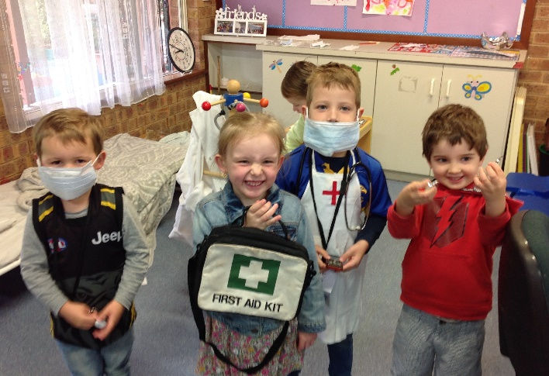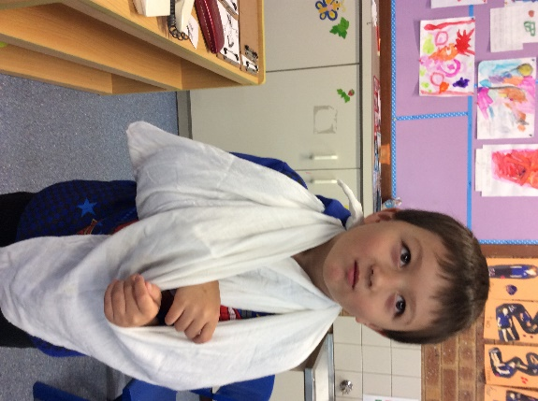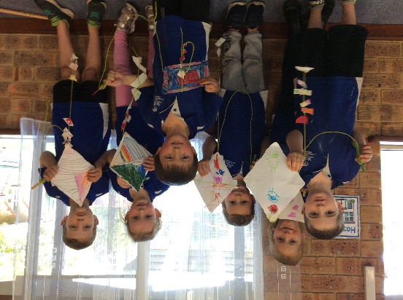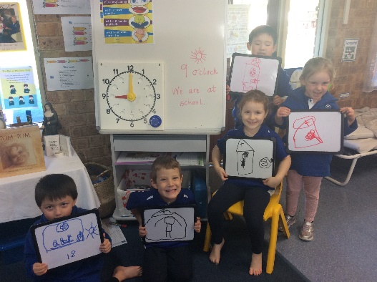

**Dramatic Play Area**

A few weeks ago, our Dramatic Play area had some major changes. With the direct planning and input of the class, we transformed our kitchen area into a hospital. While I am pleased to report that there were no serious injuries, there was some very skilled young doctors and nurses applying bandages, as well as detailed notes and x-rays of their fellow patients.

Watch out because I feel that with the recent conversations I have been hearing among the class, the hospital might be soon taking in furry and feathered patients!

It is always enthralling to support the students in creating and developing their own dramatic play areas. The ideas, language, negotiating and problem-solving skills that they use to make sure that the area is how they want it, and inclusive for all will leave many an adult in awe and amazement. True life skills in practice.

**Time for Bed Investigation**

During Mathematics we have begun a fun investigation focusing on time. Our main focus for this investigation is around our bedtime routines. We have carefully brainstormed, identified and sequenced some of the common events around our bedtime routines. We are now learning how to read time to the hour. Before we develop some yes, no questions about each other’s bedtimes and routines. Finally, we will work out ways to show the data from our questions so it’s easy to understand. (Hint – I think some graphing will be happening soon).