Annual Reporting for 2018
St Joseph’s School Pemberton

Annual School Improvement Plan
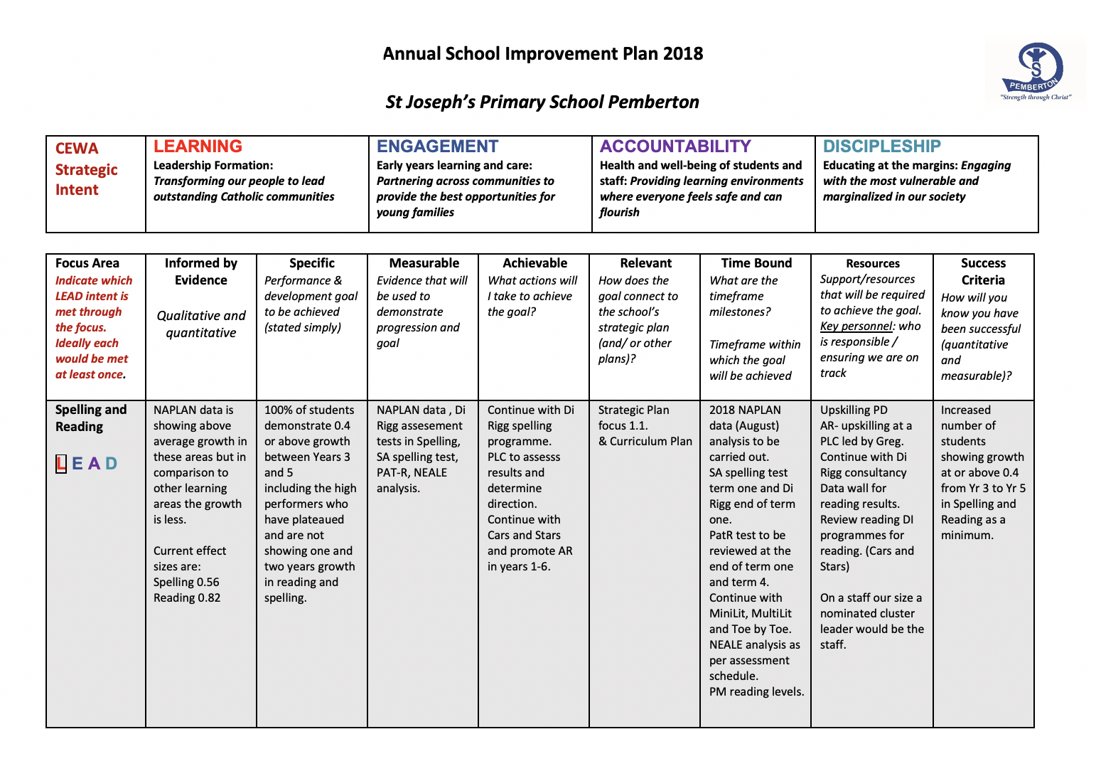

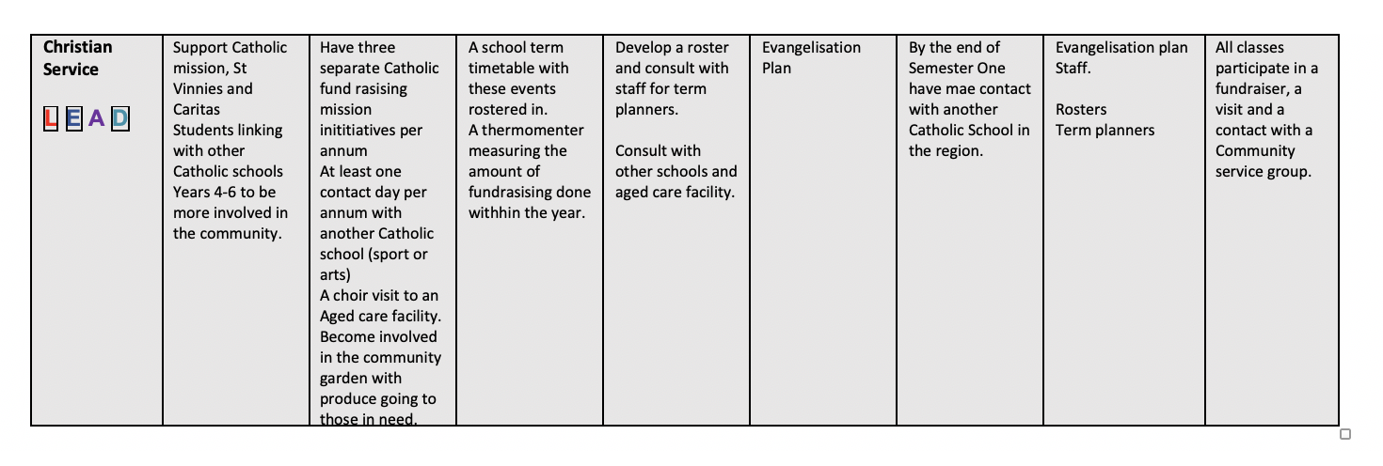

Report on progress towards the school’s ASIP goals for 2018
- While not every student demonstrated at least 0.4 growth between Year 3 and Year 5, in Reading and Spelling, the overall trends in our NAPLAN and other standardised testing data show that the school has made significant positive progress in these areas. Teacher confidence in their ability to teach reading effectively has meant that the decision has been made that there is no longer a need for the Cars and Stars program.
- Each class has been assigned one term where they plan and carry out a community service/social justice project.
- Each class has repeated their Class Assembly at the Pemberton Retirement Apartments for the elderly residents as a community service activity.
- The school has continued to be involved in the maintenance and promotion of the Community Garden.
- The school still needs to work towards making meaningful opportunities for students to engage with students of other schools.

Publication of Information Relating to St Joseph’s
This information contains contextual information about St Joseph’s School, key student outcomes, levels of satisfaction and other requirements.
1. Contextual Information
St Joseph’s School is a Catholic primary school located in Pemberton. The school is comprised of mixed age classes, allowing opportunities for extension and consolidation whilst providing a family atmosphere, where children learn from older students and consolidate understandings through mentoring younger students.

The collaborative environment strengthens community in the school and creates a positive ethos. The school’s focus is on the needs of the whole child: spiritual; physical; intellectual; social and emotional. Individuality is encouraged through developmental practice to allow each child to learn at their own pace.

The school's Early Learning Centre offers students the opportunity to work in a play-based environment consolidating skills and understandings necessary for abstract learning in later years. Both staff and students are skilled in using digital technologies to enhance the learning process. Skills are continuously developed to maximize motivation, learning potential and effective delivery. Gospel values continue to underpin the vision at St Joseph’s to develop a sense of peace, security and dignity throughout our school.
2. Teacher standards and qualifications
Teaching qualifications
All teaching staff members are registered with the Teacher Registration Board (TRBWA) and qualifications include Masters Degrees, Bachelor of Education Degrees and Diplomas/ Graduate Diplomas of Teaching. All staff members are required to undertake the relevant Accreditation requirements for teaching, leading or working in Catholic Schools as well as ongoing renewal.

- Three year trained teachers – none
- Four year trained teachers – seven
- Higher awards (Honours or Masters) – one

3. Workforce composition
Staff demographics and composition
Number of teaching staff – 7
Number of Education Assistants -2
Administration officer – 1
Groundsperson – 1
School cleaner – 1

Indigenous staff - 0
Non-indigenous staff – 12
Male – 3
Female - 9

4. Student Attendance at St Joseph’s
In 2018, the average attendance rate for the entire school was 92%. Attendance rates for each year group were as follows:

Grouping | Average rate of attendance
K/PP/1 | 89%
Year 2/3 | 94%
Year 4/5 | 90%
Year 6 | 94%

Overall, the attendance rate is high and absences are due to genuine illness.
If a student is absent from school, a parent is required to contact the school by 9.30 am. A written note must also be supplied to the class teacher explaining the absence on the day the student returns. If a parent does not contact the school when their child is absent, the school will contact the parent/guardian via a written letter. If a student has a high number of absences then a parent is required to attend an interview with the Principal.

5. NAPLAN Information
The table below shows the NAPLAN performance of St Joseph’s students compared to schools with similar students in 2018:
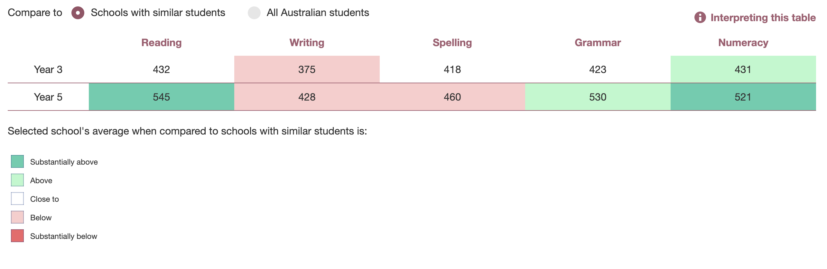
Please note – class numbers are very small. One student in a class of four who is below the minimum standard can bring the percentage down to 75%.

6. Parent, student and teacher satisfaction

Visitors to our school often comment on the friendly and warm welcome they receive. An overwhelming majority of parents expressed gratitude, happiness and satisfaction with the way the school operated in 2018.

Students are happy, eager learners who are proud to be at this school. They treat each other with respect and dignity and truly reflect the vision of the school in this way. The pastoral care demonstrated by the students for each other in St Joseph’s is very evident and has been a priority with the introduction of the MJR (Making Jesus Real) program.

Our teachers are very satisfied with the school and this is confirmed through the high retention rate of staff is indicative of the satisfaction that our teaching and non-teaching staff have with St Joseph’s School.

All parents, students and teachers are continually encouraged to raise issues or concerns with the appropriate personnel within the school.
7. Post-school destination
Students from St Joseph’s usually move on to Kearnan College, Manjimup, with some attending Pemberton District High School and some attending Manjimup District High School. We are a ‘feeder school’ for Kearnan College for those families who choose to continue in Catholic Education.

8. School Income
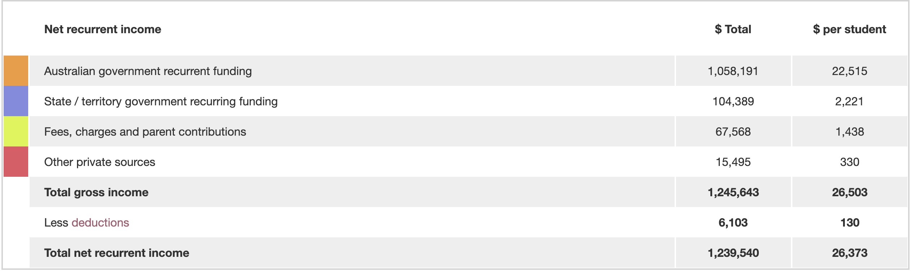
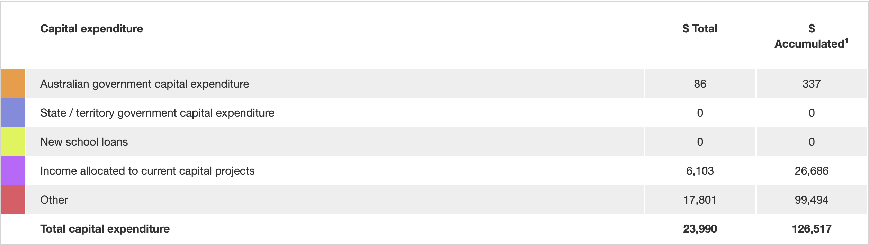
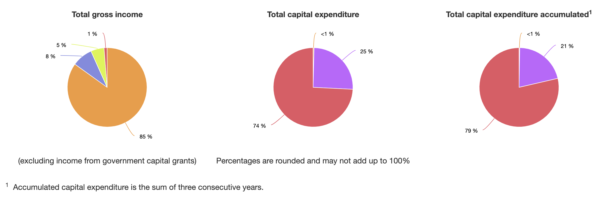

Board Chair Report to the School Community 2018
As we reach the end of another successful year at Saint Joseph’s, it is incredible to stop and think about how many different things happen in our little school in just one year! 2018 has seen many highlights, with so many people contributing in so many ways.
I would firstly like to thank the staff, led by Mr. Wilkie, for their dedication and work that they do in teaching our children. The staff do their very best to not only help our children learn, but also to ensure that our children are cared for and nurtured. So many of the staff are so willing to get involved in the life of the school, contributing outside of their own classrooms and assisting with anything that needs to be done. Thanks for everything that you do.
In my role on the P&F, I am often approaching other parents for assistance with various school events and activities. Many of you have helped in lots of ways to ensure that we are providing great experiences for our kids. Thanks for always going out of your way and rearranging your schedules to pitch in and give a hand when required. So much of what we do is only possible through a team effort
There have been a number of great events that have been led by the P&F in 2018. We had a fantastic School Disco, celebrations for Sacraments and Fathers Day, the recent Treasure Hunt day amongst other events. While these events have been great for building community, we have also been able to raise funds that have contributed towards reading resources and other purchases that benefit our children.
From a School Board perspective, we have once again enjoyed great cohesion at our Board Meetings, with many decisions made as to how we can continue to improve our school. Thanks to the members of the Board for giving up their time to attend the meetings, to help make sure that Saint Joseph’s continues to be a great learning environment for our kids. It is comforting to know that financially, the school is very well managed and in a good position for the future. Thanks especially to Rose Moyle, who always ensures that we have the information that we need for our meetings.
Saint Joseph’s is such a special place with so much to offer. I have enjoyed being so heavily involved with the school this year, with the support of many other parents. Let’s look forward to an even bigger and better 2019!

Vanessa Roche
School Board and P&F President

Principal’s Report to the School Community 2018
"Do all you can with the means at your disposal and calmly leave the rest to God." Saint Mary MacKillop
As I begin my annual report, the above quote, from such a special Saint, epitomises to me the educational community that is Saint Joseph’s. We work together, tirelessly as a community, to provide the very best experience for our children. At the same time, we place our faith in God, assured that he will embrace us and provide for our needs.
What a wonderful year 2018 has been; my first at Saint Joseph’s. I am truly blessed to have been given this opportunity to work in such a vibrant and caring community. Clearly, a very special culture has developed here over many years. I would like to take this opportunity to thank all of those in our community for being so welcoming towards the Wilkie family. We have certainly felt the warmth of the community on countless occasions, as we have settled in to a new town and school.
I would like to thank the St. Joe’s students for all of their hard work, but also for the way they treat people. I constantly admire the way our students display respect and compassion in their interactions with others. In particular, I would like to acknowledge our graduating group of Year 6s. To Jayden, Xander, James, Kaas, Toby, Isabella, Taya, Dawn, Kameka, Charli and Mia- you are each talented people in your own right and I am sure you will be very successful in everything you do in the future. You have left a tremendous mark on our school. While I’ve only known you for a year, I will always remember fondly the leadership class from my first year at Saint Joe’s. I also wish to acknowledge those families who have their youngest child graduating this year. To the Fox, Hartnett and Bendotti families- thank you for entrusting us with the education and care of your children. You have each been wonderful families who have contributed to our school in so many different ways. I thank you and wish your families nothing but the best for the future.
2018 has seen so many achievements, but none would be possible without the support of an amazing group of staff members. Our staff give their heart and soul to the school and have a genuine desire to see the students in the school thrive in every way. I would like to especially thank Mrs. Rose Moyle, who has been a constant source of support and information for this rookie Principal- thanks for your patience and dedication Rose! I acknowledge also the contribution of Miss Emma Moynihan and Miss Shontel Licari, who will not return to the school next year. They have each had an enormously positive influence on the students in their care. Both young ladies are fine teachers, but even better people and I wish them all the best for their future endeavours. I also send my best wishes to one of the longest-serving members of our staff, Mrs Leanne Mazzarolo, who will continue to be on leave in 2019 as she pursues her many other passions in life. We look forward to you returning to our school in the future Leanne, as you are such a valued member of our community.
Any effective school can only succeed in partnership with parents. The children in our school come from such beautiful families, where they are loved unconditionally and assisted in their learning. I would like to personally thank the parents for their support this year. There have been numerous times where parents have put their hands up to assist with canteen, uniforms, P&F events, carnivals and other activities. These efforts have not gone unnoticed or unappreciated. I would like to especially acknowledge those parents who have served on the School Board and/or P&F Executive this year. It is a real credit to our small school that we can so easily find parents to volunteer their precious time to serve in these roles. It is something that I have certainly not taken for granted.

The Parish and School continue to enjoy a close relationship. This year, we have once again successfully run our Sacramental programs, as well as participating in a range of Masses and Liturgies. I wish to extend my thanks to Father Robert, who leaves our parish at the end of the year. Father Robert has been a great source of spiritual guidance for all of us here at Saint Joe’s. One thing that I have admired about Father Robert is the way that he always shows a deep and genuine concern for the students. You will be greatly missed, Father- all the best for the future.
This year, I have really admired the way that our students have lived an active faith in seeking opportunities to serve others through social justice activities. Our Year 6s have embraced Vinnies, with a number of initiatives designed to support this great organisation. They have also looked for opportunities to become involved in our local community, with activities such as performing at the Retirement Apartments. We also had some students from Year 4/5 show their charitable spirit in organising a jumble-sale to raise money for those in need. I encourage our students to continue to be ‘people for others’.
Through working together, we have achieved so much at our great school in 2018. Whether it be our considerable academic success, our sporting endeavours or achievements in the creative pursuits, we have so much to be proud of this year. We approach 2019 with confidence that we will continue to be a place where students, strengthened through Christ, can continue to flourish in all that they do. Have a happy and safe Christmas and holiday break.

Brett Wilkie
Principal

